POLYNOMIAL REGRESSION

## What is Polynomial Regression?

## Types of Polynomial Regression

1. Linear – if degree as 1

2. Quadratic – if degree as 2

3. Cubic – if degree as 3 and goes on, on the basis of degree.

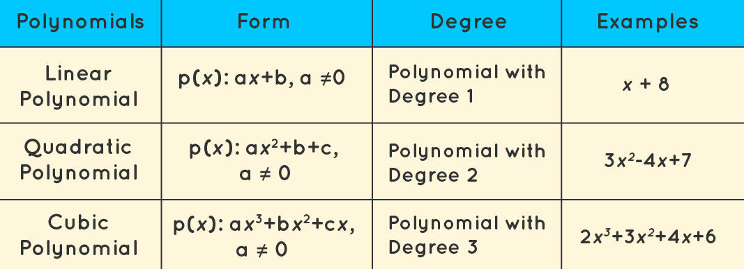

## math to understand Polynomial Regression

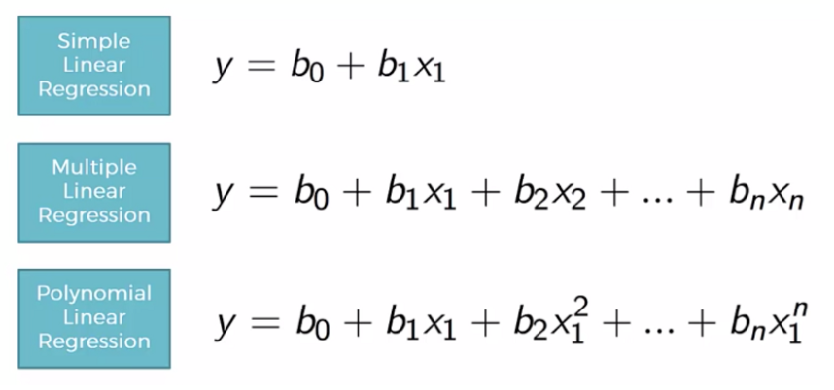

## Linear Regression Vs Polynomial Regression

Rather than focusing on the distinctions between linear and polynomial regression, we may comprehend the importance of polynomial regression by starting with linear regression. We build our model and realize that it performs abysmally. We examine the difference between the actual value and the best fit line we predicted, and it appears that the true value has a curve on the graph, but our line is nowhere near cutting the mean of the points. This is where polynomial regression comes into play; it predicts the best-fit line that matches the pattern of the data (curve).

One important distinction between Linear and Polynomial Regression is that Polynomial Regression does not require a linear relationship between the independent and dependent variables in the data set. When the Linear Regression Model fails to capture the points in the data and the Linear Regression fails to adequately represent the optimum conclusion, Polynomial Regression is used.

Before delving into the topic, let us first understand why we prefer Polynomial Regression over Linear Regression in some situations, say the non-linear condition of the dataset, by programming and visualization.